Pope Francis asks, 'Do you want to live like a light that is on or off?'
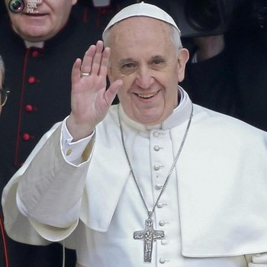
Pope Francis
Pope Francis Facebook
Originally published Feb. 9, 2014
In Sunday's address to those gathered in St. Peter's Square, Pope Francis reflected on the Gospel of Matthew (5:13-14). "You are the salt of the earth.... You are the light of the world". According to Zenit News Agency, Pope Francis told those gathered that this gospel directly follows the Beatitudes.
In his address, Pope Francis asked "Who were those disciples? They were fishermen, simple people. But Jesus looked upon them with the eyes of God and his statement should be understood precisely as a consequence of the Beatitudes. He wishes to say: If you will be poor in spirit, if you will be meek, if you will be pure of heart; if you will be merciful....you will be the salt of the earth and the light of the world."
Pope Francis explained the gospel's images, saying that Jewish Law prescribed putting a little salt upon every offering to God, as a sign of the covenant. "Light, for Israel, was a symbol of the messianic revelation that triumphs over the darkness of paganism. Thus, Christians, the new Israel, received a 'mission' for all men; with faith and charity they can direct, consecrate, and make humanity fruitful. All of us baptized are missionary disciples and we are called to become a living gospel in the world; with a holy life we will give 'taste' to the different spheres of society, and defend them from corruption just as salt does; and we will bring the light of Christ, with the witness of a genuine charity. But if we Christians lose our taste and extinguish our presence as salt and light we will lose effectiveness."
Pope Francis continued: "But how beautiful is this mission to give light to the world! It is a mission we have. It is beautiful! It is also very beautiful to keep that light that we have received from Jesus, protect it and keep it. The Christian must be a shining person, who brings light, who always gives light! A light that is not his, but a gift from God, it is Jesus' gift. And we carry this light. If the Christian extinguishes this light, his life has no meaning. He is Christian in name only, he does not bring light with him, his light is without meaning. But I would like to ask you now, how do you want to live? Do you want to live like a light that is on aor one that is off? On or Off? How do you want to live? (The people gathered responded "On!") A light that is on! It is God himself who gives us this light, and we give it to others. A light that is on! This is the Christian vocation"
Following the Angelus, Pope Francis spoke about Feb. 11, the memorial for Our Lady of Lourdes when we will observe the World Day of the Sick. He asked everyone to pray for the sick and to be close to them. He quoted St. John "Faith and Charity: We ought to lay down our lives for one another (1Jn 3:16). "In particular," he said, "we can imitate the attitude of Jesus toward the sick; the sick of every sort. The Lord cares for them; shares their suffering and opens their heart to hope."
Pope Francis thanked health workers saying how precious their work is. "The attitude toward the sick that is generous and Christian," he said, "is salt of the earth and light of the world. May Mary help us to practice and obtain peace for all those who are suffering."
Pope Francis concluded his address with the following statement:
And before I depart the question I asked comes back to my mind. Light on or light off? What do you want? On or Off? The Christian brings light! He is a light that is on. Always forward with the light of Jesus!"

Suggested Links
- How much do you know about the Apostles?
- Twenty five popular patron saints women may select for their confirmation name
- Twenty five popular patron saints for men to consider as their confirmation name
- How much do you know about the sacraments of the Catholic Church?
- Five popular apparitions of the Blessed Virgin Mary

